



**36_Rank Scores Problem**

Write a pyspark code to rank scores. If there is a tie between two scores, both should have the same ranking. Note that after a tie, the next ranking number should be the next consecutive integer value.In other words, there should be no “holes” between ranks.

**Difficult Level :** MED

**DataFrame:**

**# Define the schema for the DataFrame**

**schema = StructType([**

**StructField("Id", IntegerType(), True),**

**StructField("Score", FloatType(), True)**

**])**

**# Data to be inserted into the DataFrame**

**data = [**

**(1, 3.50),**

**(2, 3.65),**

**(3, 4.00),**

**(4, 3.85),**

**(5, 4.00),**

**(6, 3.65)**

**]**

|  |
| --- |



**INPUT**

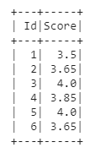

**OUTPUT**



